**EXTRA PRACTICAL QUESTIONS (26 NOV 2020)**

1. **Print the sum of three numbers.**

**CODE:**

#include<iostream>

using namespace std;

int main()

{

cout<<"Welcome, This Program Adds\n";

cout<<"Enter Three Numbers\n";

int a;

int b;

int c;

cout<<"\n First Number= ";

cin>>a;

cout<<"\n Second Number= ";

cin>>b;

cout<<"\n Third Number= ";

cin>>c;

int sum=a+b+c;

cout<<"\n The total is:"<<sum;

cout<<"\n Thank You and Have a Nice Day"<<endl;

system("pause");

return 0;

}

***TERMINAL OUTPUT:***

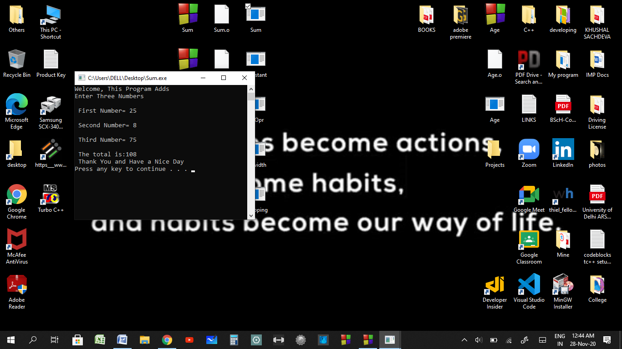

1. **Three ways to use constants.**

**CODE:**

#include<iostream>

using namespace std;

#define PI3.14159

int main()

{

const double PI=3.14159;

cout<<"Define Constant PI:"<<PI<<"\n";

cout<<"Memory Constant PI:"<<PI<<"\n";

cout<<"Literal Constant PI:"<<PI<<"\n";

system("pause");

return 0;

}

***TERMINAL OUTPUT:***

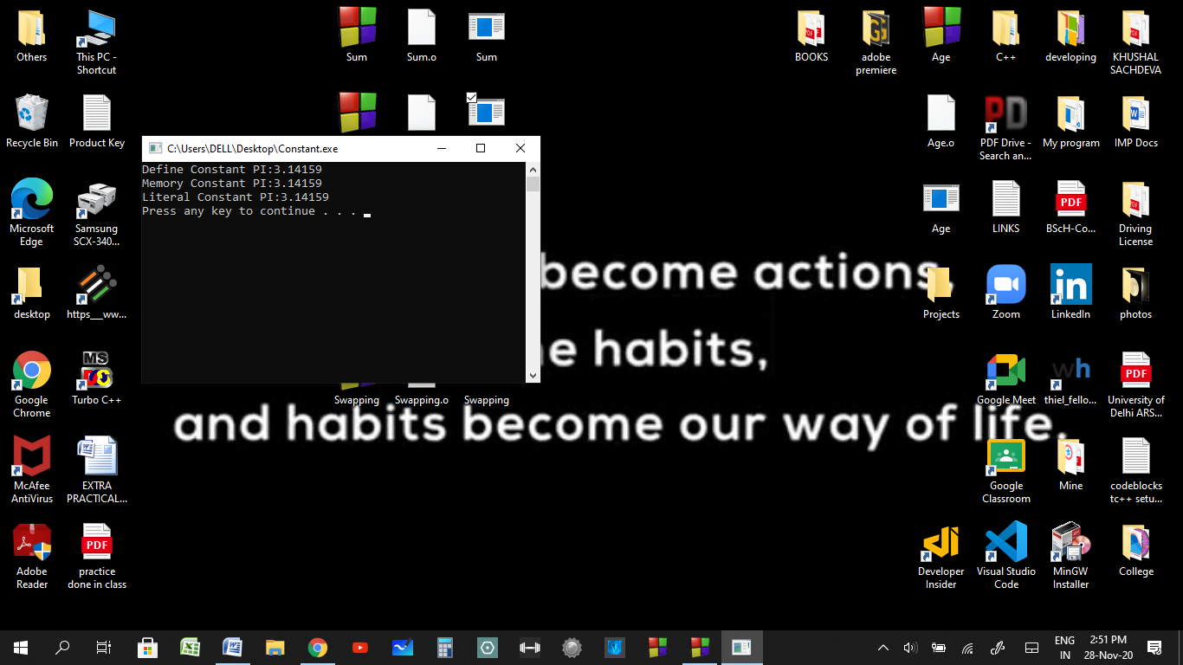

1. **Use of insertion operator.**

**CODE:**

#include<iostream>

using namespace std;

int main()

{

cout<<24<<"\n";

cout<<12.3<<"\n";

cout<<"A"<<"\n";

cout<<"Hello"<<endl;

system("pause");

return 0;

}

**TERMINAL OUTPUT:**

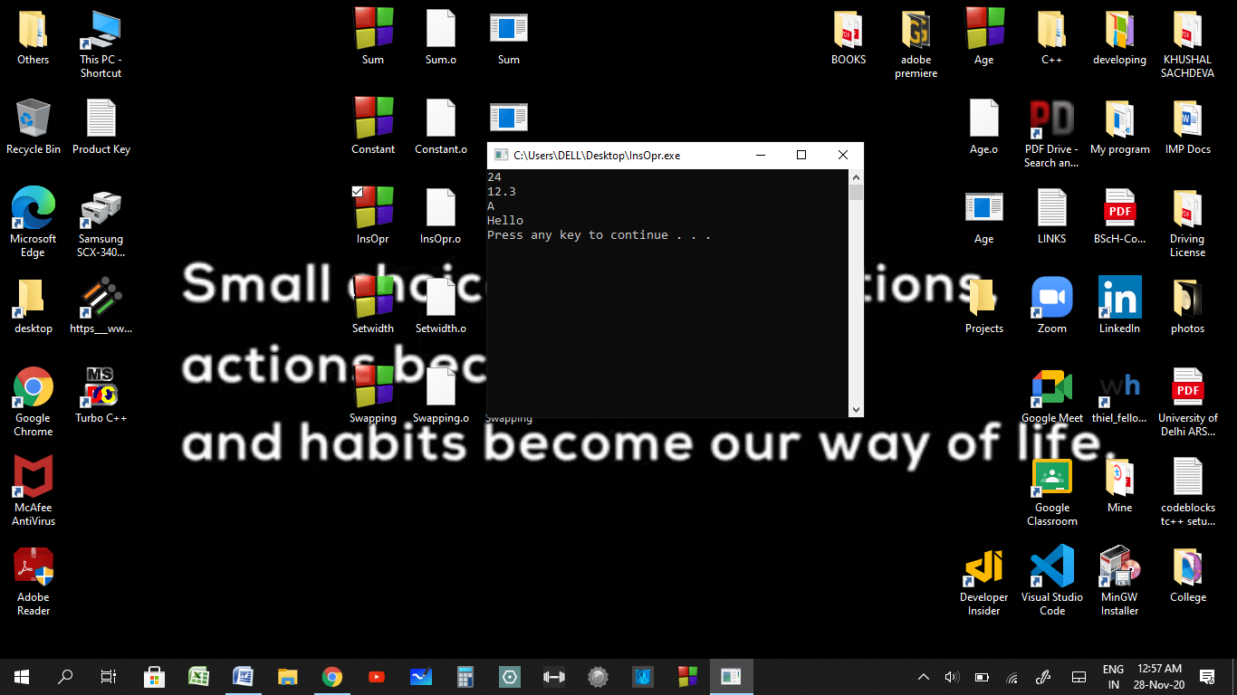

1. **Use of Setwidth (setw) manipulator.**

**CODE:**

#include<iostream>

#include<iomanip>

using namespace std;

int main()

{

int d=123;

float f=1.23;

char ch='A';

cout<<"Demonstrate set width manipulator"<<"\n";

cout<<setw(5)<<d<<"\n";

cout<<setw(5)<<f<<"\n";

cout<<setw(5)<<ch<<"\n";

system("pause");

return 0;

}

**TERMINAL OUTPUT:**

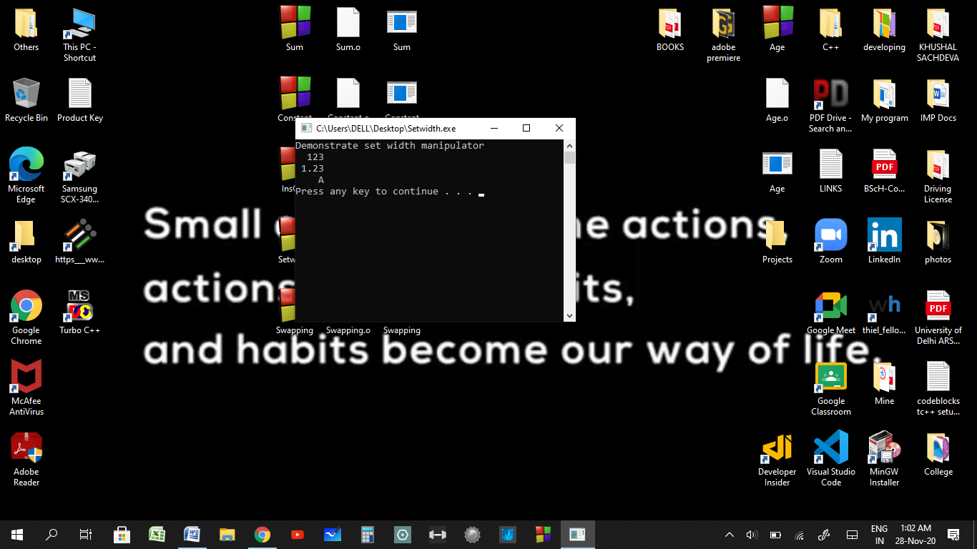

1. **Swapping two numbers.**

**CODE:**

#include<iostream>

using namespace std;

int main()

{

int a;//Declaration

int b;//Declaration

cout<<"Enter Two Numbers Here \n Number 1= ";

cin>>a;

cout<<"/n Number 2= ";

cin>>b;

a=a+b;

b=a-b;

a=a-b;

cout<<"The Numbers after Swapping are \n Number 1= "<<a<<"\n Number 2="<<b<<endl;

system("pause");

return 0;

}

**TERMINAL OUTPUT:**

